18 - George Michael – Faith
Original: B Us: Same Practice the comp pattern
YAM:organ3, piano1 or WURLI
[Intro] Organ solo (see below)
[Verse]
B | B | B | B | E | E | B | B [2x]

[Chorus]
E | E | B | B | E | E | B | B
E | E | B F#/A# g#m | g#m
c#m | c#m | F#7 | F#7 (break)
B | B | B | B | B | B | B | B (break)

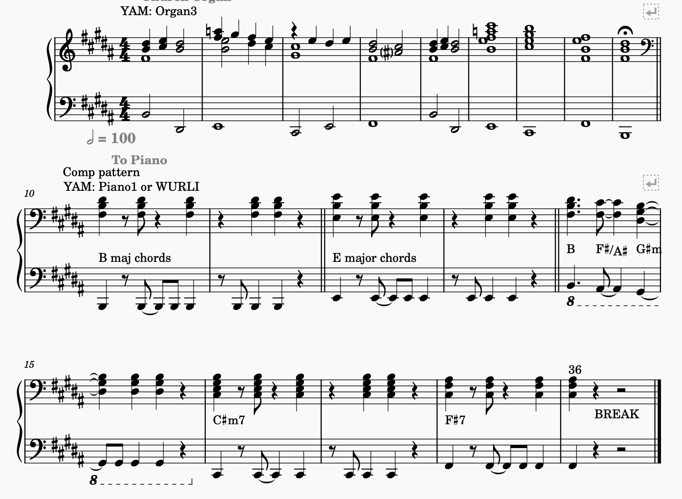
[Solo] one verse, then Chorus

